November 2019

The Walled Garden
It’s been a busy summer and autumn in the walled garden. I had great success with my brassicas especially the kale ( ‘Black Magic’, ‘Dwarf Green Curled’ & ‘Scarlet’), purple sprouting broccoli and the brussel sprouts. I did, however, struggle with slugs devouring the pak-choi in the salad bed but, all in all, it has been a great learning experience.
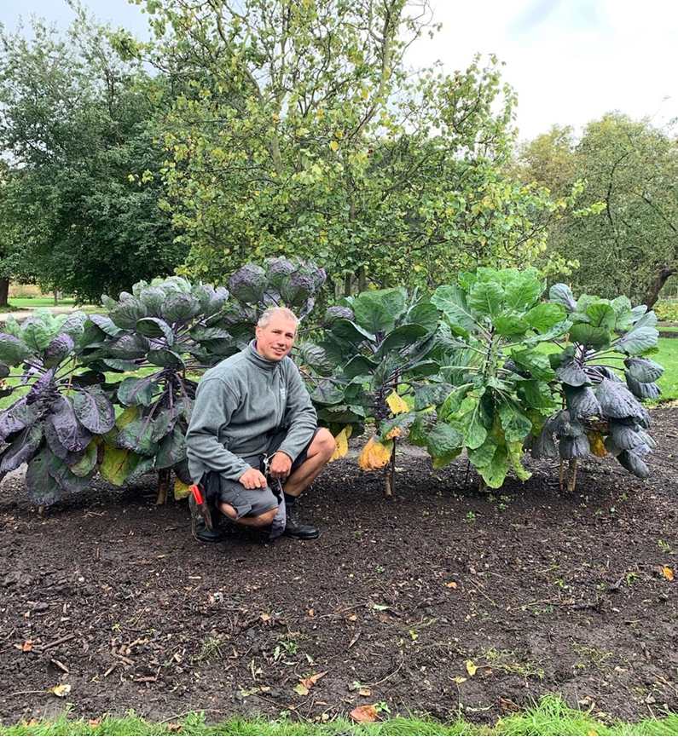 | 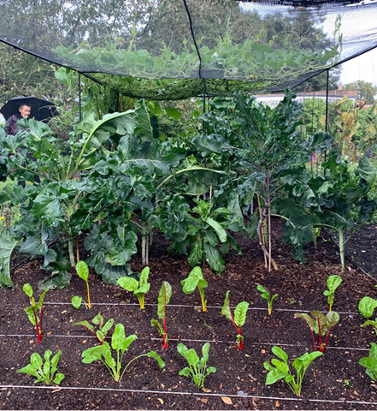

I’ve also enjoyed growing a variety of flowering annuals and short lived perennials in the spaces around the vegetables; learning about their flowering times, size, spread, colour, etc. in order achieve a satisfactory display. My favourite flowers this year have been: i) Rudbeckia hirta ‘Cappuccino’ with its incessant display of flower heads with a brown central disc surrounded by bronze petals that bleed into yellow at their tips, and ii) Ipomoea lobata a twining climber with three-lobed leaves, sporting crimson-flushed stems bearing one sided racemes of small, tubular, dark red flowers which fade to orange and then creamy yellow in summer.

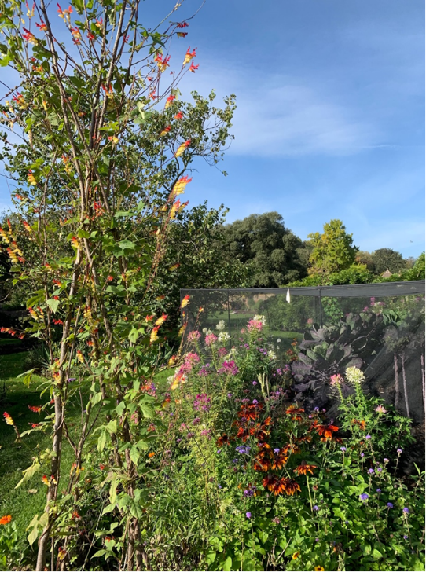

The end of the long and productive growing season was marked by the annual apple day celebration. It was a great success and gave us the opportunity to run short tours around the garden sharing our knowledge and insights.

Another great, albeit painful, learning experience was the discovery, at the end of the summer in the cucurbita’s bed, of a fungal infection called sclerotinia stem rot. This is a fungus that lives in the soil and affects many vegetables and ornamental plants by making them rot at the base, while a white fluffy mould grows on affected parts. Fortunately, all the apprentices had not long been put through knapsack pesticide application training which allowed us (once we had cleared all the beds!) to treat the infection. We only use organic techniques in the walled garden and fortunately the treatment was spraying a another fungus (Contans WG) that predates on sclerotinia, and so keeping within our organic remit. Immediately after application we had to rotovate all the affected area to incorporate the “good” fungus into the soil.

As autumn closes in we have found ourselves busy mulching, leaf collecting, bulb planting & preparing cuttings to increase our plant stock.

Around the Palace
In addition to our new Compton beds, which I mentioned in my last update, we have been really busy improving the grounds for the enjoyment of our visitors this includes:
- Preparing a site for a new children’s play area
- Levelling ground for a new shrubbery bed in the north side of the palace
- “Recreating” the old Moat on the east side of the palace by planting a variety of blue bulbs which we hope to enjoy in the spring

As my 18 month apprenticeship enters its final months I feel extremely excited about what the future holds for me. This placement has afforded me the opportunity to work with a great team who’s passion & knowledge has helped foster a wonderful learning environment for me. I will leave Fulham Palace as a more confident, knowledgeable and qualified gardener!

Alfonso Moreno

