Denny Trust Visit to Fulham Palace 2023

On Tuesday 25th April Trustees, Jenny and Clara, made the first visit since the Covid 19 Pandemic to Fulham Palace to meet with Head Gardner Lucy Hart and the most recent Apprentice, Patricia, recipient of Denny Trust funding.

We met initially with Lucy, Sian and Patricia for a light lunch in the Café, a chance to catch up on how the Pandemic affected Fulham Palace and the people that worked there. We heard how the team managed the garden during this time and supported local residents with produce from the gardens. It was also interesting to hear how events such as the annual Apple Festival and the newer Green Meet are bringing new visitors to the Palace, building awareness and also raising funds.

The weather was bright and promising for a trip around the gardens after lunch to see the latest developments. After frost affected the Wisteria plants last year signs are hopeful for a good flowering display this year. Another couple of weeks and I think the plants will be at their best and very impressive. The newly designed and manufactured ironwork support for the Wisteria in the walled garden is impressive and beautifully crafted. Lucy updated us on additions to the Compton Border, how these have been researched and sourced. Sian was able to tell us about the contacts made with local and university researchers to further investigate the Compton collections. As we made our way into the walled garden Patricia was able to show and explain her work and focus over the last year especially in the vegetable beds. The volunteer teams were working away in the vegetable beds, planting up companion plants to encourage pollination as well as deal organically with some potential pests encouraging ladybirds, and other insects into the gardens. We caught glimpses of the four new resident hens who have recently started laying eggs and met Edmond the Cat who helps control the mice in the garden as well as engage with visitors as and when he is in the mood. We didn’t see Monkey, the newer cat but both are playing their part in the sustainable and organic aims of the gardening team here.

We finished with a look around the museum and the latest exhibition; The Bishops of London, colonialism and transatlantic slavery: resistance. The Church of England was deeply implicated in Britain’s colonial expansion and the transatlantic traffic in enslaved Africans. The Bishop of London, who lived at Fulham Palace, was one of the Church’s most senior figures, having had jurisdiction over the British colonies around the world. The exhibition showcases the work of the community participants and examines the systems of physical and spiritual resistance that ultimately led to the ending of the transatlantic traffic in enslaved people and slavery itself in the British Empire. This is set against the backdrop of the historic involvement of the Bishop of London and the Church of England in colonialism and transatlantic slavery.

A refreshing cup of tea and piece of cake in the Café was the perfect end to our visit allowing us to reflect on the continued benefit of the Denny Trust support for the Apprentice position. We wished Patricia well as she moves on to Kew Gardens to start her Diploma. Fulham Palace is gaining a reputation all of its own for the gardeners who start their learning here and the Denny Trust is glad to be playing a small part in that.

A few pictures below of our visit:

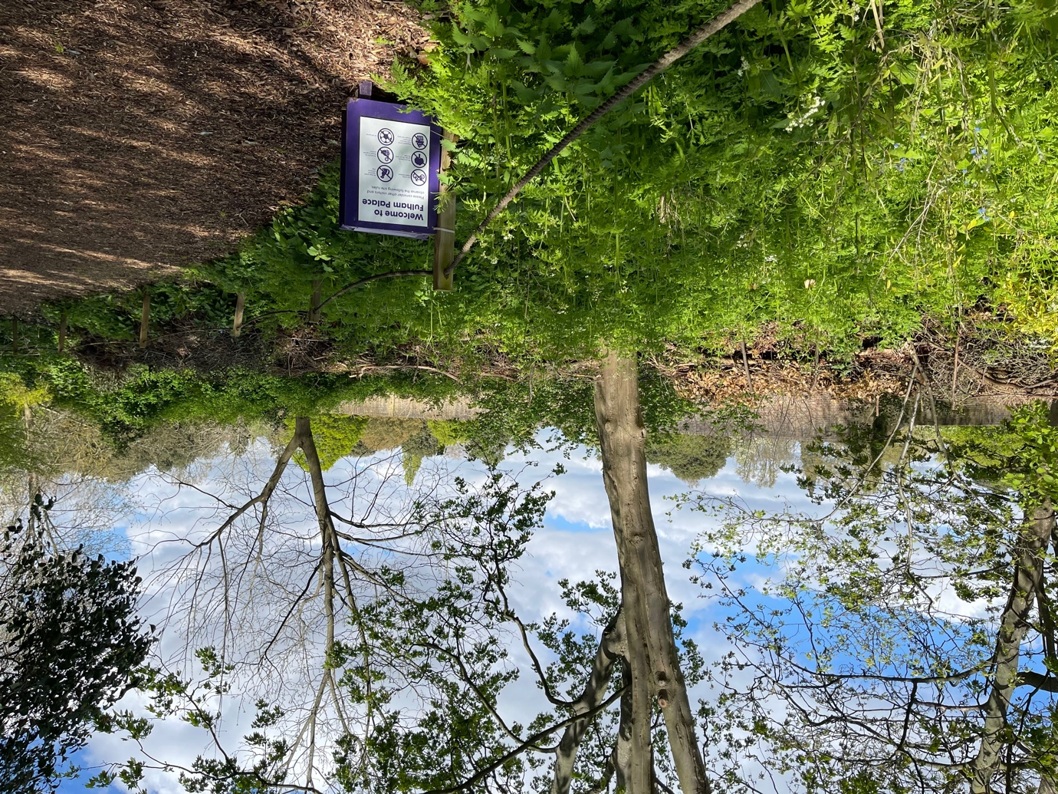

Encouraging wildlife in the borders outside the walled garden
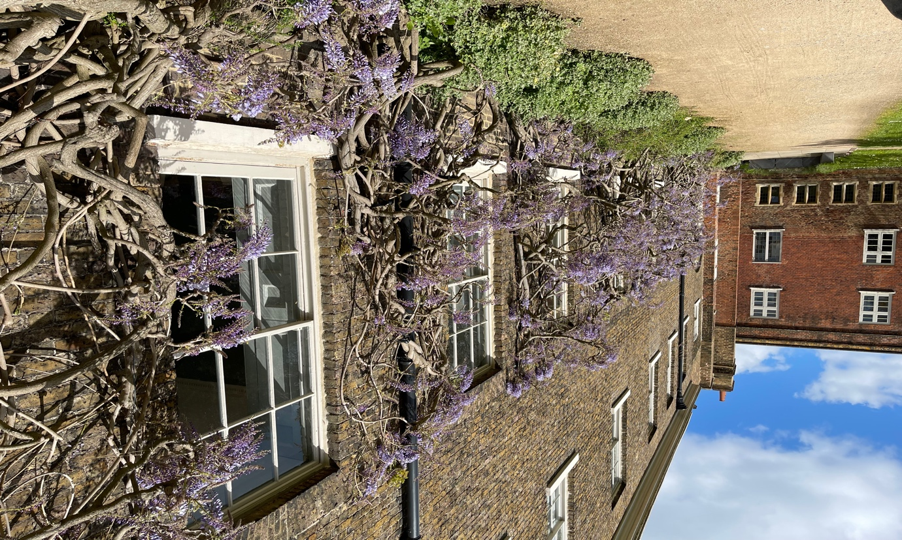

Wisteria well pruned and about to come into flower on the Palace wall (above and below)

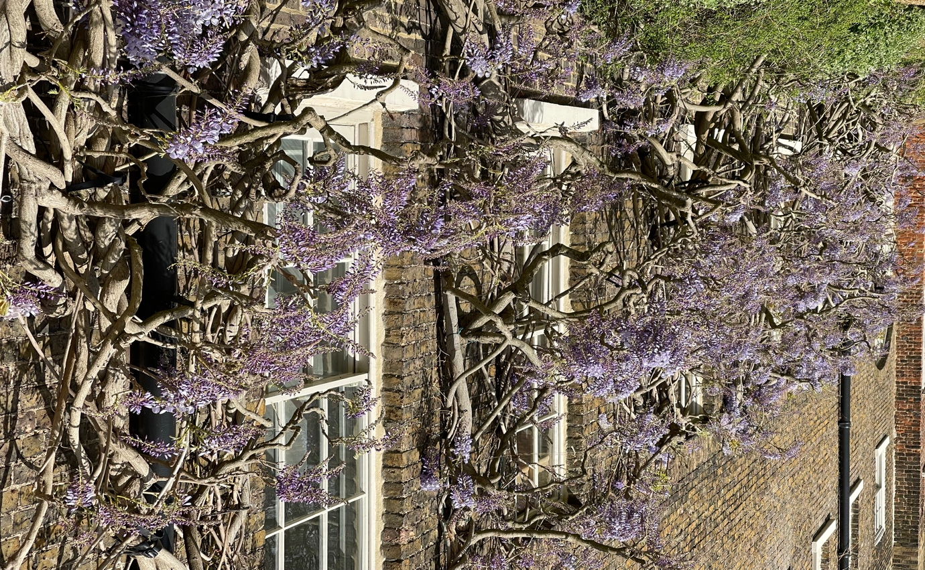

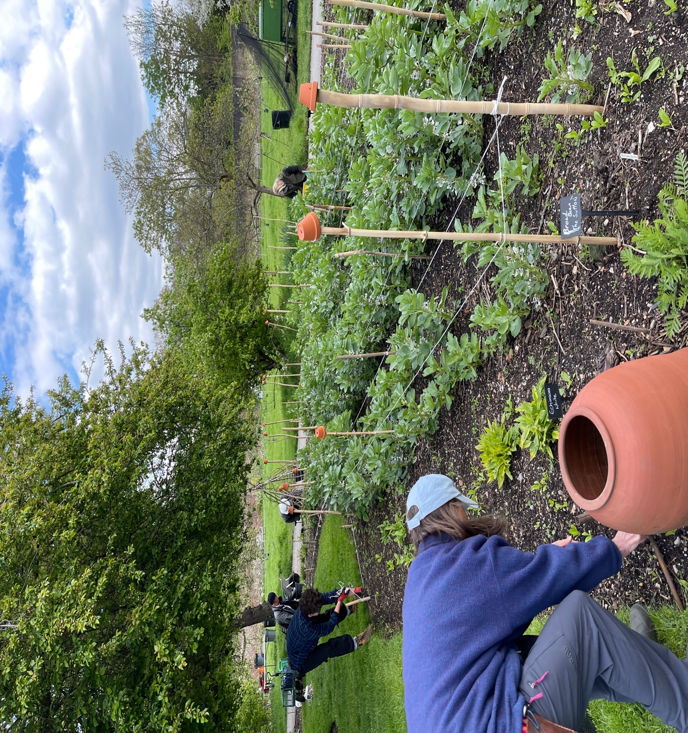

Volunteers working in the vegetable beds
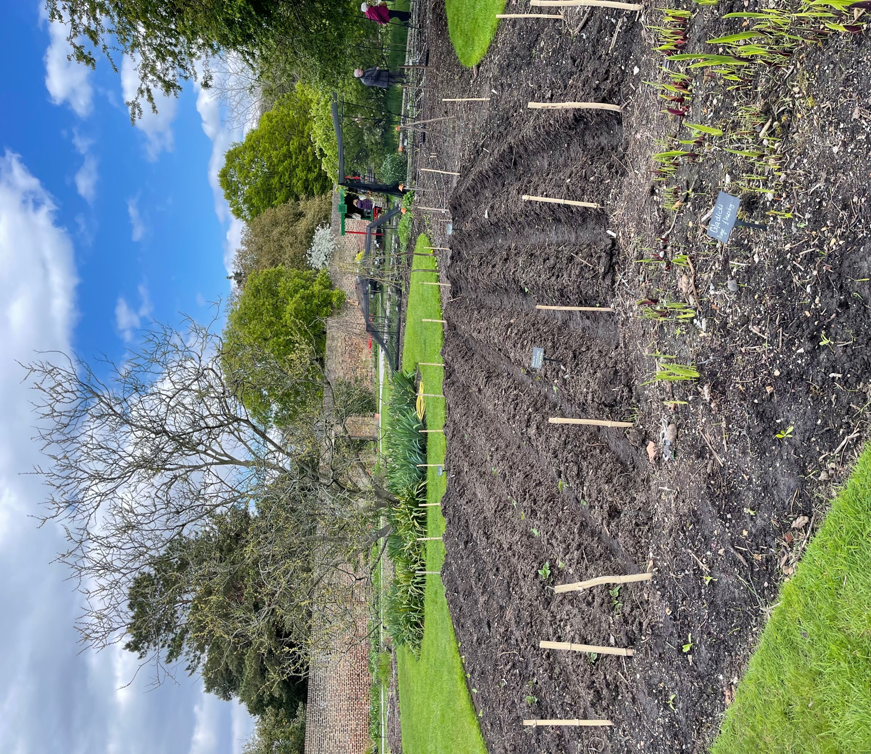

Potatoes planted
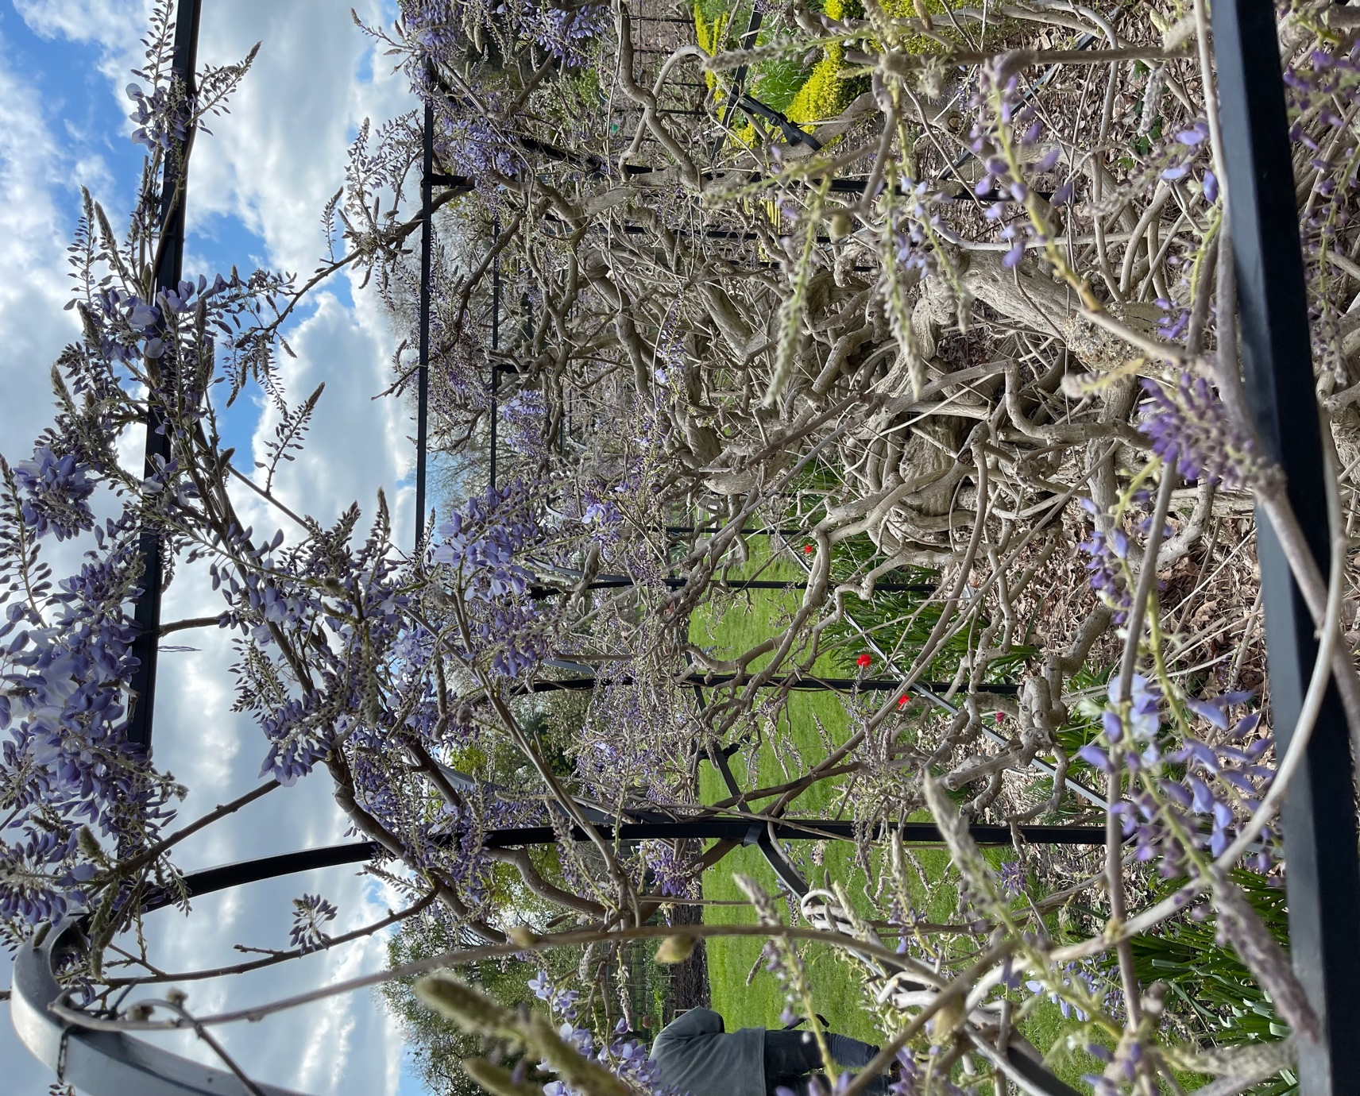

Wisteria coming into bloom, also a good view of the new ironwork support
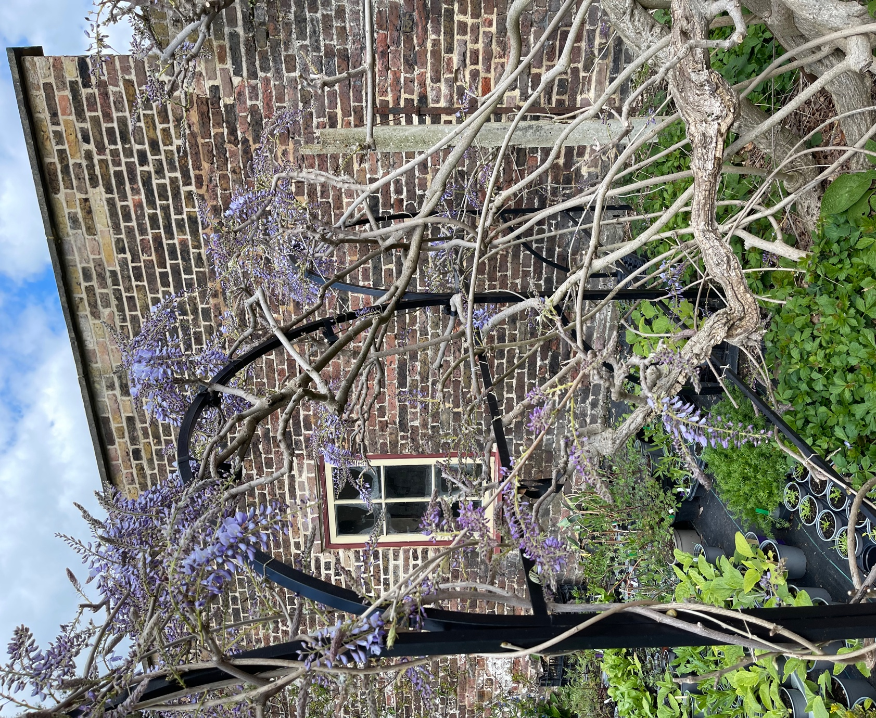

Another good view of the purpose built ironwork support
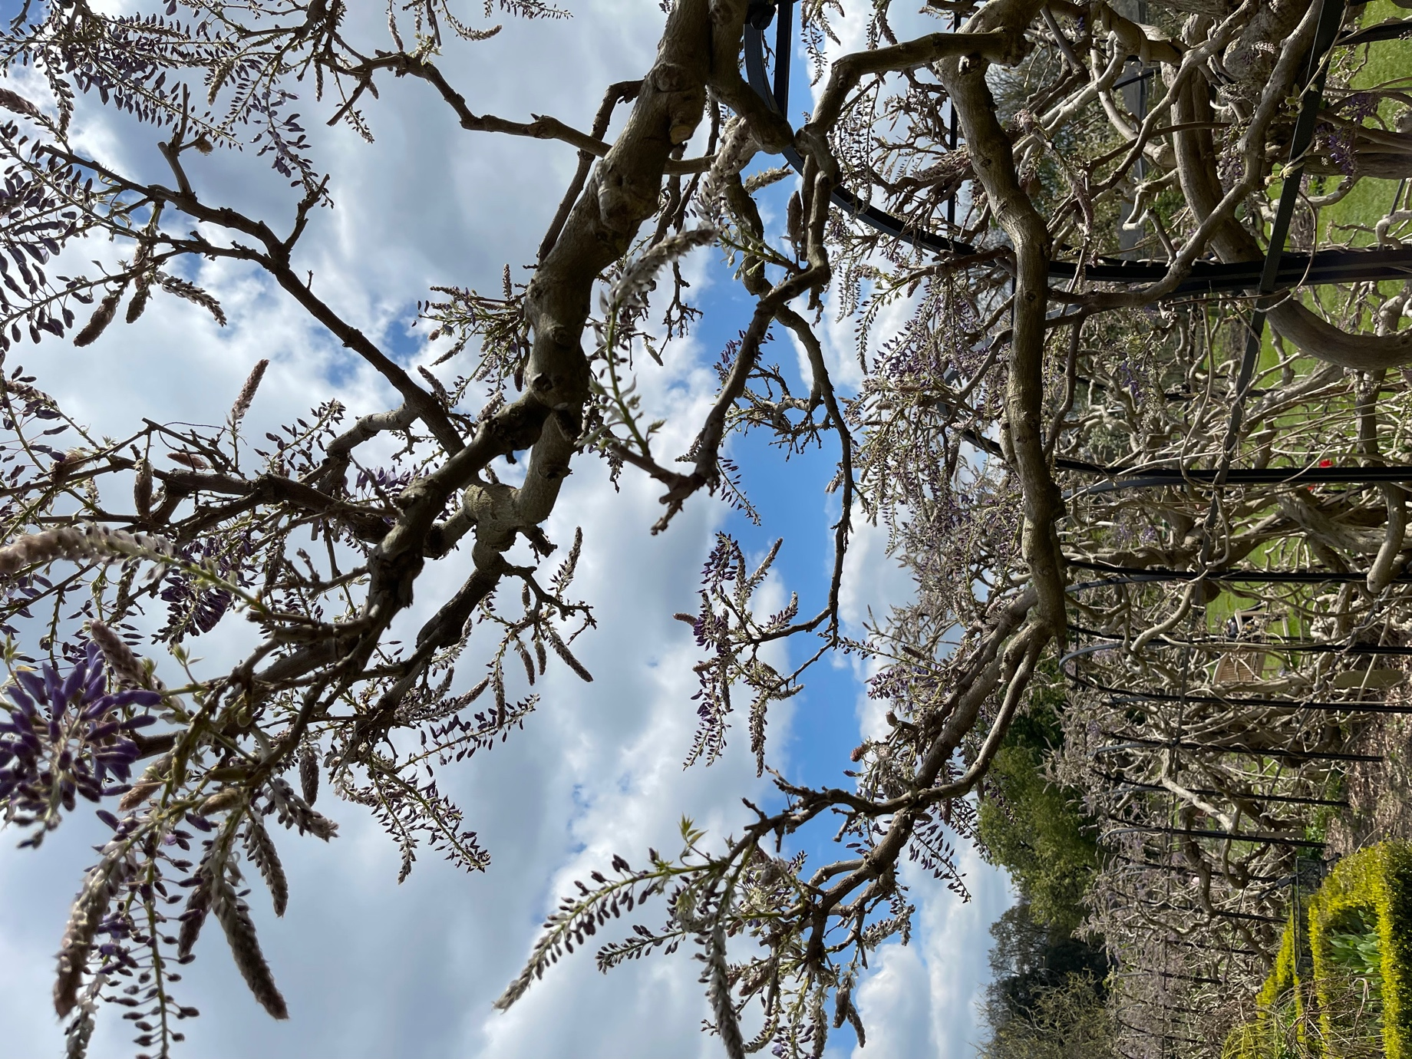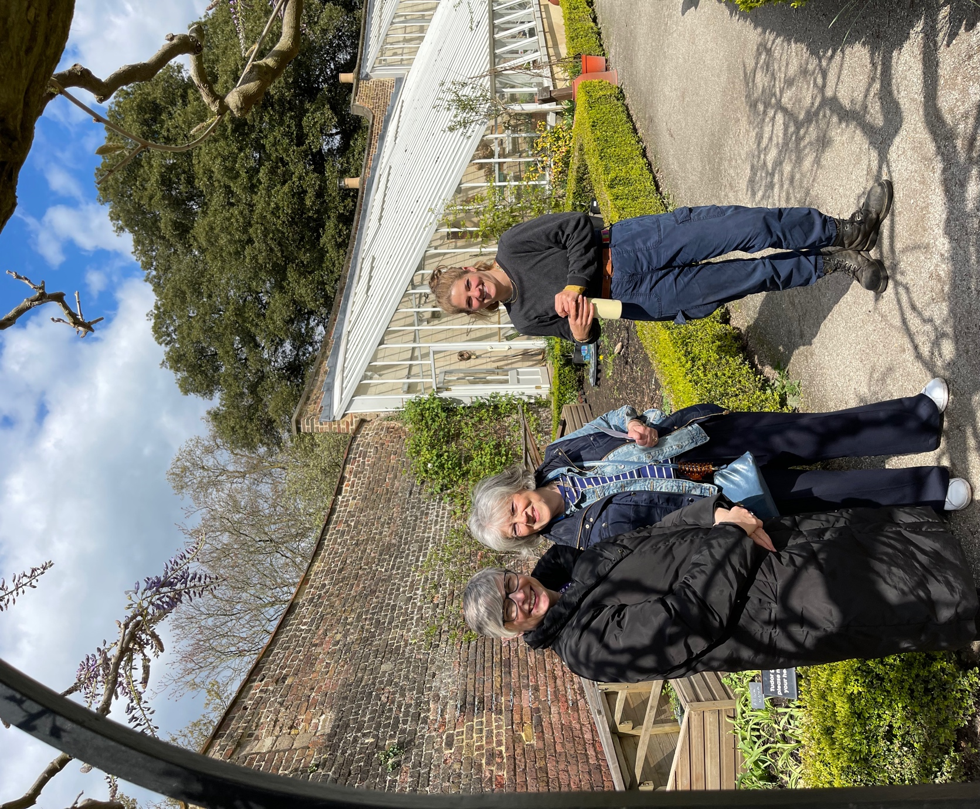

Sian, Jenny and Patricia in the walled garden. Bright and sunny but coats still needed!
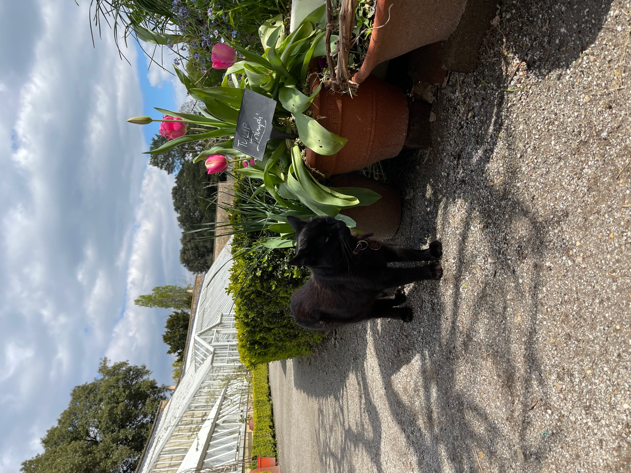

Edmond the cat
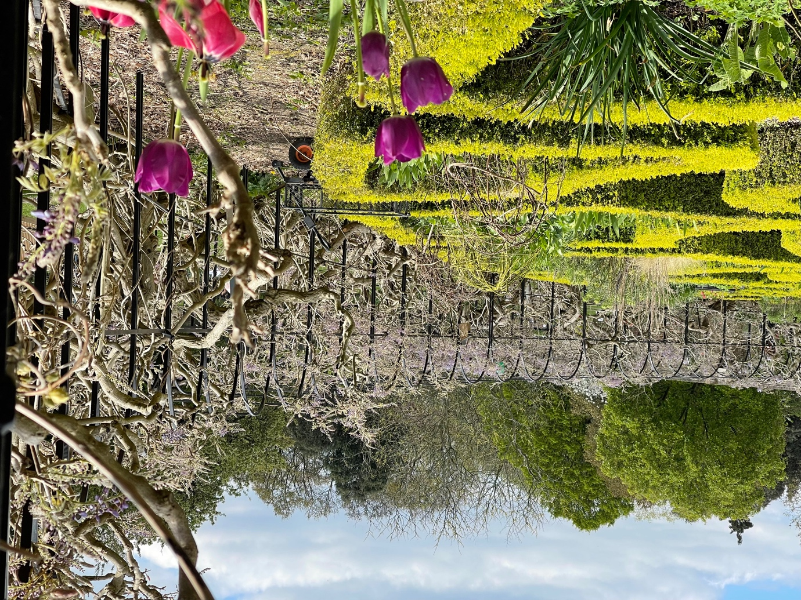

Another view of the Wisteria and support
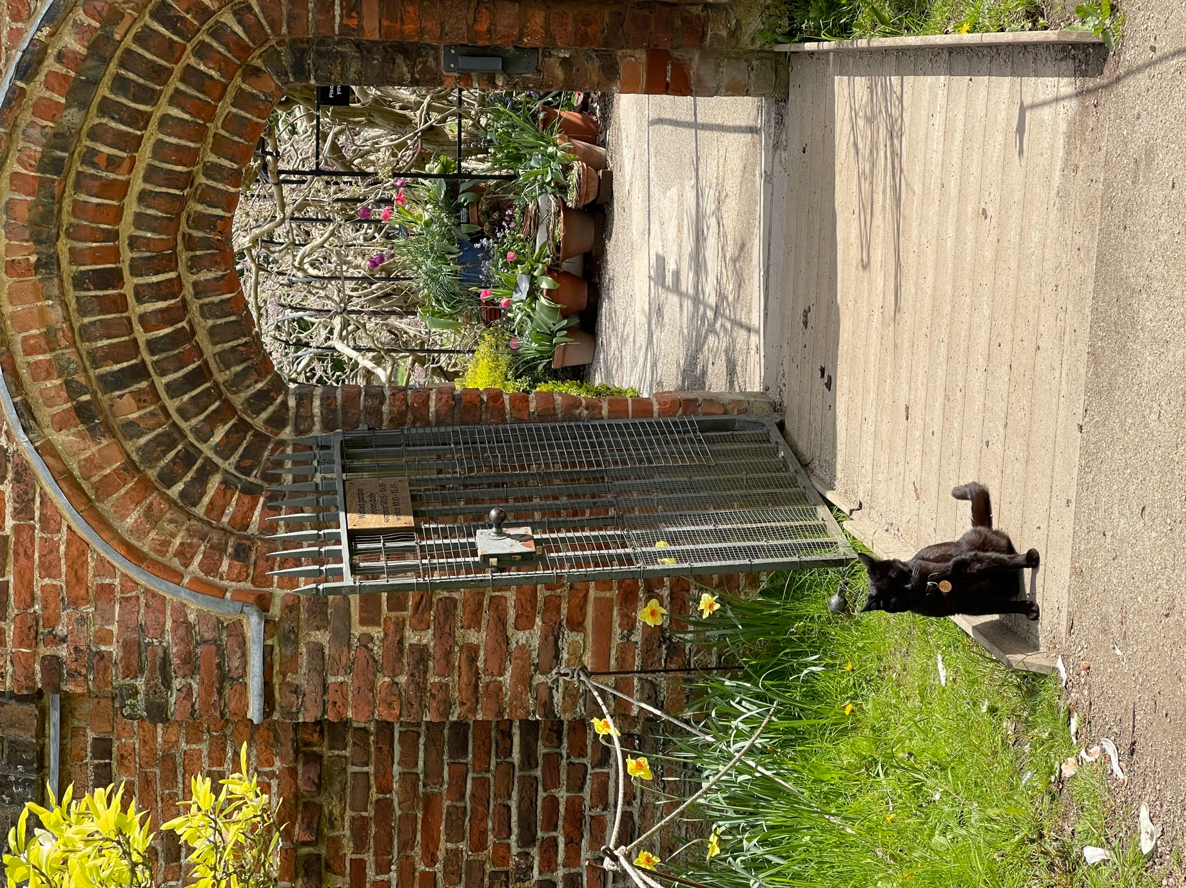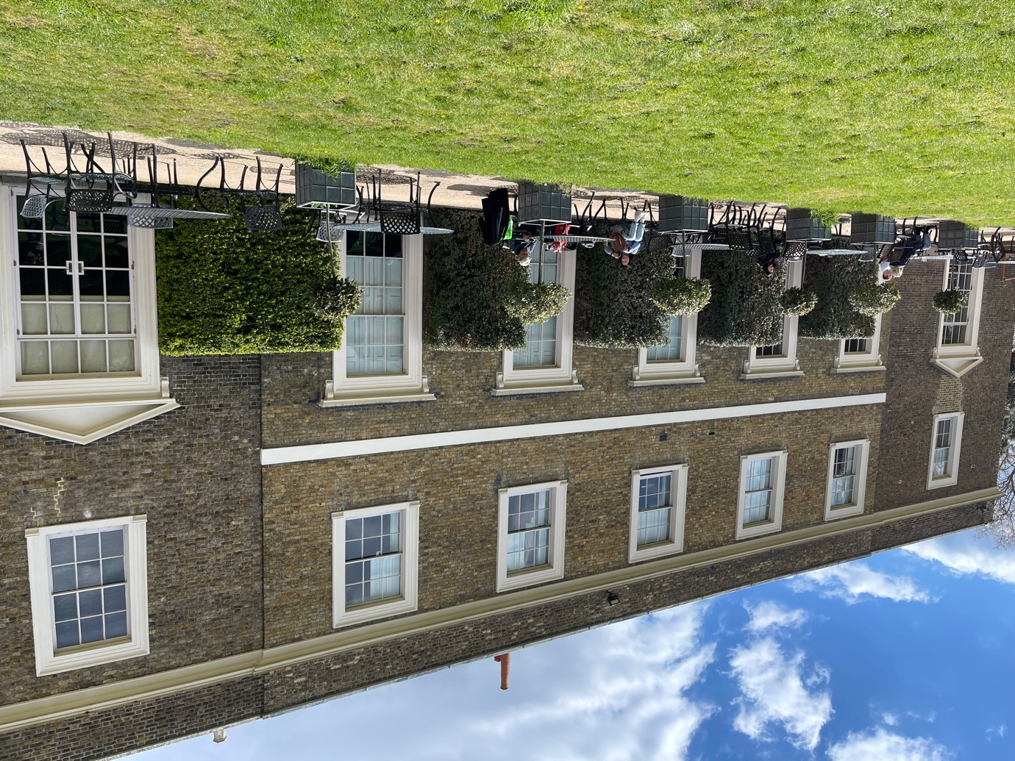

Palace looking good in the sun.

